Memories of Edith
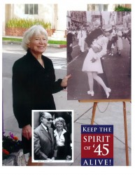
Edith Shain, the "Times Square Nurse" devoted the last years of her life to campaigning for a National Spirit of '45 Day.
The KEEP THE SPIRIT OF ’45 ALIVE family lost a dear friend and devoted advocate when Edith Shain, the nurse from the iconic “Times Square Kiss” photograph passed away on June 20, 2010 at the age of 91.
Click here to visit “A Tribute to Edith Shain”.
Edith was a devoted spokesperson for KEEP THE SPIRIT OF ’45 ALIVE. She always gently deflected the admiration and attention that inevitably came her way, reminding audiences that her famous moment was a symbol of a greater story.
(Click once to play video. Click twice to see on YouTube.)
Edith Shain Tribute (Linda Laurie, Warren Hegg, Channel 10 News (San Diego)) | Edith Shain with David Louie, Channel 7 News (San Jose) | Edith Shain with Chuck Scarborough, Nightly News (New York)
She was a representative of a generation that came together in America’s time of need, and in doing so, not only won a war, but set an example of service and national unity that continues to inspire us today.
And, befitting someone whose moment in the spotlight was shared by a serviceman, she always made a point of reminding us that the true sacrifices had been made by our men and women in uniform and their families.
We are proud to have known and worked with Edith, and to have been inspired by her energy, warmth and devotion. We offer our condolences to Edith’s surviving family and friends, and we pledge to carry on the cause that she so passionately championed, to keep her spirit — and the Spirit of ’45 — alive forever.

Read Edith Shain’s story of how she became the “Times Square Nurse.”

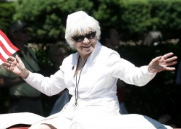
Edith appeared as Grand Marshal in the 2008 National Memorial Day Parade in Washington, DC
National Spirit of ’45 Day originated with Edith Shain, the nurse who was photographed being kissed by a unidentified sailor in New York’s Times Square on August 14, 1945 – the day the world learned that the war was over and the work of peace began.
The photo, taken by Albert Eisenstadt appeared on the cover of Life Magazine and became the iconic symbol of the end of World War II, recognized by people the world over.
Using her “accidental celebrity,” Edith campaigned tirelessly for a permanent annual day that would ensure that her generation’s achievements could inspire a new generation of ordinary heroes to come together to face the complex issues and challenges America is struggling with today.
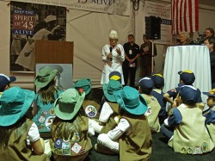
Edith speaking to a group of Boy and Girl Scouts at a Spirit of '45 rally in San Jose, California in February 2010.
As former elementary school teacher, Edith was especially concerned that America’s young people be a central part of this national effort by contributing their talents, energy and idealism to help build a better future for themselves and their country.
She frequently met with youth leadership group to encourage them to become “the ordinary heroes of the 21st century” through service to their community and civic engagement.
Although Edith passed away suddenly at age 91 on June 20, 2010, her vision of a national day of renewal to bring people of all ages and backgrounds together in common cause is now becoming a reality.

(Click once to play video. Click twice to see on YouTube.)

