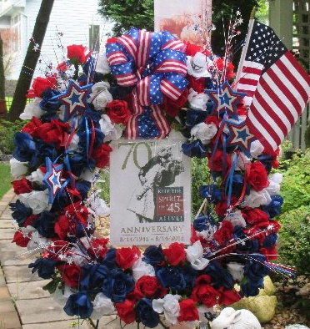
DATE/TIME
INSERT PICTURE
(USE 3:2 RATIO PICS FOR BEST FIT)
LOCATION
ADDRESS
OTHER DETAILS

<REPLACE WITH YOUR EVENT INFO. GRAPHICS WILL APPEAR CORRECTLY WHEN PRINTED/SAVED AS PDF>

